**AM. SC. P2CSC19011**

**ANUSREE P R**

**Cryptography and Network Security**

**Assignment – 1 – Solutions**

**PART – A**

**1)a belongs to Zp. Prove that (a + p)n(mod p) =an(mod p)**

Using binomial theorem,

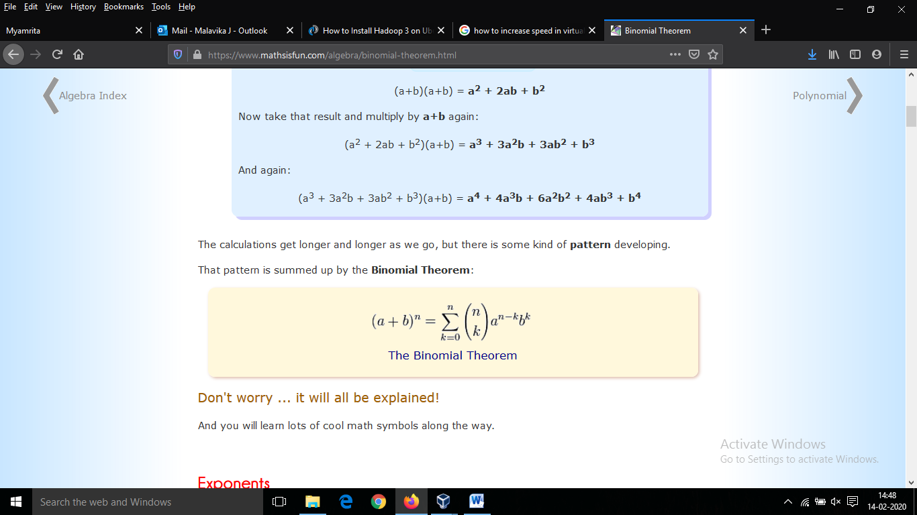

On applying this to (a + p)n(mod p)=an+pn mod p

rest of the terms becomes 0 since(p mod p=0)

(a + p)n(mod p)=an+pn mod p

=an mod p + pn mod p

=an mod p + 0

=an mod p

Hence proved.

**2) Find the multiplicative inverse of all the elements in Z5 and Z11.**

**Ans:** Multiplicative Inverse of:

**Z5:**

|  |  |  |  |  |
| --- | --- | --- | --- | --- |
| a | 1 | 2 | 3 | 4 |
| a-1 | 1 | 3 | 2 | 4 |

**Z11:**

|  |  |  |  |  |  |  |  |  |  |  |
| --- | --- | --- | --- | --- | --- | --- | --- | --- | --- | --- |
| a | 1 | 2 | 3 | 4 | 5 | 6 | 7 | 8 | 9 | 10 |
| a-1 | 1 | 6 | 4 | 3 | 9 | 2 | 8 | 7 | 5 | 10 |

**3) Determine the gcd of 56245 and 43159.**

**Ans:** 56245=43159*1+13086

43159=13086*3+3901

13086=3901*3+1383

3901=1383*2+1135

1383=1135*1+248

1135=248*4+143

248=143*1+105

143=105*1+38

105=38*2+29

38=29*1+9

29=9*3+2

9=2*4+1

2=1*2+0

Therefore, gcd(56245,43159)=1.

**4) Compute phi(n) for 34 and 210.**

**Ans:** According to Euler’s product formula:

Phi (34) =34*(1-(1/3))

=81*2/3

**ANS:** =54.

Phi (210) =210*(1-(1/2))

=1024*1/2

**ANS:** =512.

**5) Compute 3100 mod (31319).**

**Ans:**  2 100 – 0

2 50 – 0

2 25 – 1

2 12 – 0

2 6 – 0

2 3 – 1

2 1 – 1

0

Here expo=100 =>26+25+24+23+22+21+20

32^0mod (31319) = 3 mod (31319) = 3

32^1 mod (31319) = (32^0)2mod (31319) = 9

32^2 mod (31319) = (32^1)2mod (31319) = 81

32^3 mod (31319) = (32^2)2mod (31319) = 6561

32^4 mod (31319) = (32^3)2mod (31319) =14418

32^5 mod (31319) = (32^4)2mod (31319) =21979

32^6 mod (31319) = (32^5)2mod (31319) =12185

3100 mod (31319) =12185*21979*81 mod (31319)

=5346*81 mod (31319)

**ANS:** =25879.

**PART-B**

1. **Write a program to implement Extended Euclidean Algorithm and find multiplicative inverse for following values.**

Code:

#include<iostream>

using namespace std;

int Exteuc

(int a, int b, int *x, int *y)

{

if (a == 0)

{

*x = 0, *y = 1;

return b;

}

int x1, y1;

int gcd = Exteuc(b%a, a, &x1, &y1);

*x = y1 - (b/a) * x1;

*y = x1;

return gcd;

}

int main()

{

int a, m;

cin>>a>>m;

int x, y;

int g = Exteuc(a, m, &x, &y);

if (g != 1)

cout << "\n Inverse does not exist. ";

else

{

int res = (x%m + m) % m;

cout << "\nMultiplicative inverse of( "<<a<<","<<m<<") is "<< res;

}

return 0;

}

1. **53947-1 mod 56211**

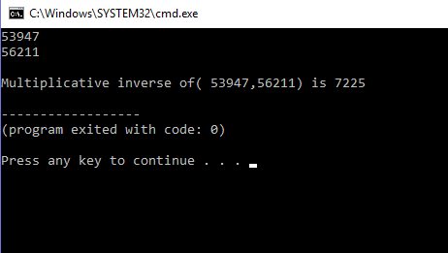

1. **19385-1 mod 431592**

